

# 

UDPTester Guide

October 26, 2015

*© 2015 Amber Road, Inc. All rights reserved. This document contains Amber Road, Inc. confidential and proprietary information and is for internal use only. Use of any part of this document without the express written consent of Amber Road, Inc. is prohibited.*

Amber Road | One Meadowlands Plaza | East Rutherford, NJ 07073 | (T) 201 935 8588 | (F) 201 935 5187 | www.AmberRoad.com

Table of Contents

1. Introduction 3

1.1 Purpose 3

2. Run Procedure 3

2.1 Download tool from svn to cluster node server 3

2.2 Configuring ‘UDPTester-conf’ script file 3

2.3 Run ‘UDPTester’ script file in your cluster node server 3

# Introduction

This document describes how to use UDPTester.

## Purpose

Sometime we do not know whether our network is support multicast ip or not. So this tool will help you verify it.

# Run Procedure

## Download tool from svn to cluster node server

You should download this tool UDPTester from svn:

<http://source.ecvision.cn/svn/xpc/Source/Branch/XPC9.5/SDK/tool/UDPTester/usage>

## Configuring ‘UDPTester-conf’ script file

Open the UDPTester-conf.sh (or UDPTester-conf.bat in windows), and refer the comment on variable set the value for the following variables:

1. ’TEST_BIND_ADDRESS’

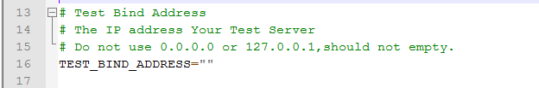

1. ‘TEST_MULTICAST_ADDRESS’

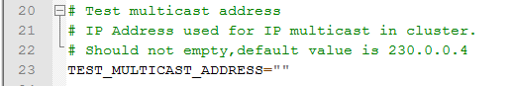

1. ‘TEST_MULTICAST_SOCKET_BINDING_PORT’

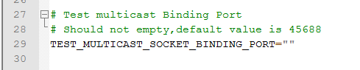

## Run ‘UDPTester’ script file in your cluster node server

1. In 1 cluster node server, run UDPTester.sh ( or UDPTester.bat in windows) .

If your network supports UDP, you will see like the following log:

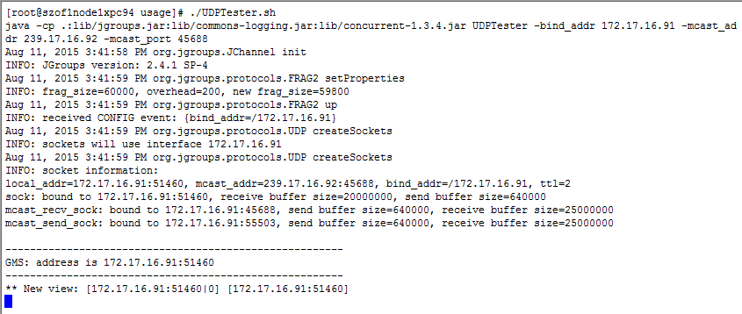

1. In 2 cluster node server, run UDPTester.sh (or UDPTester.bat in windows).

If your network supports UDP, you will see like the following log:

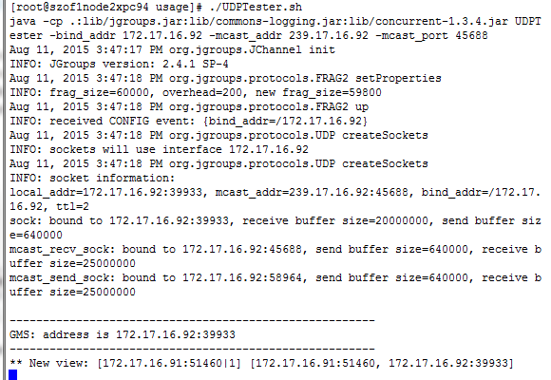

And also in 1 node server console, you will see the following log:

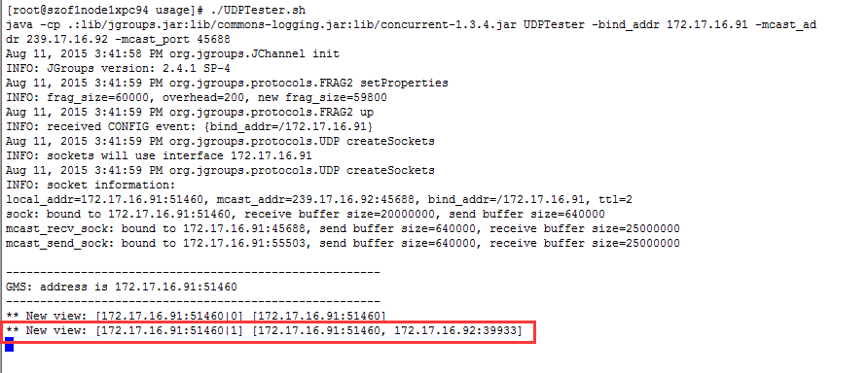

If you do not see the above log, it means your network does not support UDP